4/30/2023

**Business Analytics Assignment#03**

Section: 8-B

Instructor: Dr. Rauf Ahmed Shams

Group Members:

19K-0354 Saman Khan

19K-0357 Muhammad Farjad

19K-0360 Muhammad Areeb

# **Problem Formulation**

The major focus of this case is how to best use time series data while running a small firm in a competitive retail environment: how can data analysis improve the sales process? Choosing the best key promoting decisions is as crucial as having vision, industry knowledge, and the proper people on board. As a result, omitting the most important facts from discussions might be tremendously advantageous. Their sales are divided into categories based on the most popular flavors. They classified ice cream flavors based on their intended audience. Happy Cow has about 16 different flavors at any given moment. These included a small core set of always-available flavors such as strawberry, mint chocolate chip, and salted caramel, as well as a larger selection of seasonal flavors such as hazelnut, mango, and ginger, which were rotated for availability. A shopping list of probable flavors to stock was provided to retailers. After her team had developed and tested new flavors, Mary would occasionally release them: as winter approached in 2017, Happy Cow debuted pumpkin fudge and a low-sugar recipe. Her team of local employees developed additional flavors to better reflect local tastes: ginger was previously offered as a winter flavor because to the Chinese belief that eating warm foods in cold weather is healthy. Here are some key points about the data:

* Students, Staff, and Travelers are three client groups represented in the sales data.
* Sales data for each hour of the day.
* Data on sales from April through September of 2017.
* Data on the sales of various flavors of ice cream to each customer group (students, staff, and tourists).
* Being offered by a premise or opinion that certain flavor groups sell better at different periods of the year.

Key questions to address:

1. Which ice cream flavors and serving sizes are most popular among each customer group?
2. Are there any specific trends or patterns in sales data for daily, weekly, monthly, or hourly timeframes?
3. How do sales trends differ between customer groups?
4. What recommendations can be made for optimizing Happy Cow's strategy based on the analysis of the sales data?

# **Data Processing**

The data given is already preprocessed and cleaned. However, we still had to perform a few preprocessing steps to get the best from the data:

* The date column was not in correct format, as we were using PowerBI for visualization, we transformed the data using PowerBI’s query editor. First we split the Date column using space as the delimiter, this gave us 4 different columns that contained weekday name, date, month, and year respectively. We then merged date, month, and year columns into one to finally get the date in proper format.
* There were quite a lot of null values in Student, Tourism, and Staff columns, we replaced them according to the Product and Identity columns accordingly.
* Another issue which we faced with the data was of Data Types. When we loaded the data in PowerBI, all the columns were assigned Text as their Data Type, so we had to change the data type of different columns according to the values as well.

# **Data to Information/Knowledge Transformation**

## **Flavors Analysis:**

Following figures display sales according to the customer profile of the outlet and represented the different flavor performance in the terms of revenue generated.

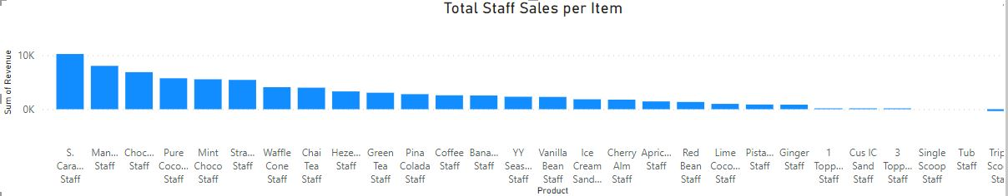

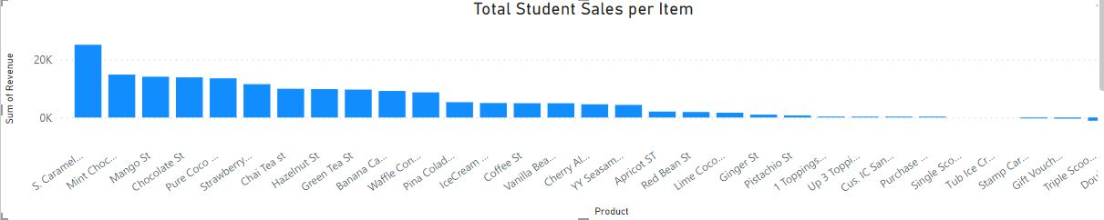

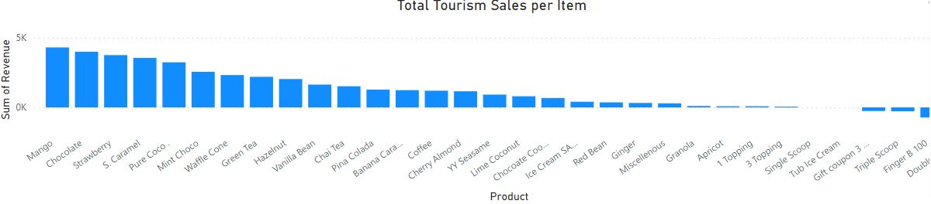

The above visualizations answer the first question. Analyzing the graphs we can infer that there are zero sales of Tub Ice Cream from all three sections of the population. This suggests that none of their customers are interested in buying ice-creams in large volumes at shops and should be kept only at markets. Apart from that, the double scoops sales and triple scoops sales are all negative, which tells us that the company provides many Special Event coupons during the promotional events with partners. Further closely examining the data it tells us that there have been 0 “sales” from double scoop ice cream and triple scoop ice cream from all three sections of the population. Further analyzing we could see that the top three flavors overall come out to be Mango, Chocolate and Caramel. Whereas Cus IC Sand was the worst performing ice cream out of the lot. Finally in terms of toppings, 1 topping is the most preferred by each customer group.

## **Sales Analysis over Time:**

The graph below answers the second question.

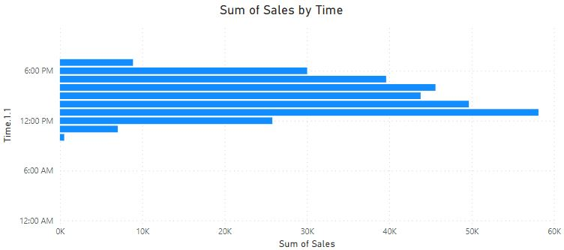

The graph above represents hourly sales for all 24. It can be seen that the time where the rush hour can be felt are 1pm to 5pm where 1pm being the busiest and 10am is the least active. We can use this data to decide the hours where more staff should be employed so that the customers are always satisfied and the company do not over employee or under employee. This can help Happy Cow Ice-Cream not only in terms of customer satisfaction, but also cost management.

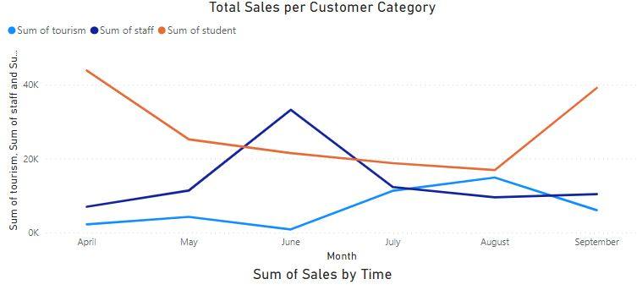

The light blue bar indicates monthly sales for tourists, the orange bar represents monthly sales for students, and the dark bar represents monthly sales for staff. The graph above reflects monthly sales for all six months from April to September. From the following graph, it can be seen that the majority of Happy Cow sales are generated by students in April and September, with the smallest number of sales occurring in June. The month of June is the busiest for sales from staff, while April and September are the slowest for them. August is the busiest month for tourism sales, with the smallest amounts coming in during June and April. We could understand the peak in the student line as this would be when the study term is going on in April and mid-May. After the study term, there is a fall in the sales as they would have their exams followed by summer vacation. Once their winter term starts, the sales go back to normal. With the staff, we could see that their peak sales are in mid-June (post the exam period) as they would like to have a treat after checking the paper. As the number of tourists is the highest during the summers, we also see a peak in their sales during July and August.

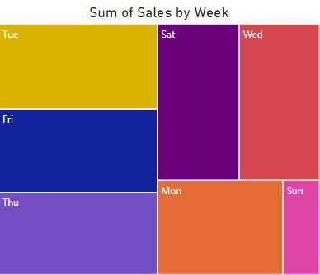

The graph above reflects weekly ratio of sales for all days in a week from Monday to Sunday. From the following graph, it can be seen that the majority of Happy Cow sales are generated on Tuesday, with the smallest number of sales occurring on Sunday which is understandable as the campus is not open on Sunday.

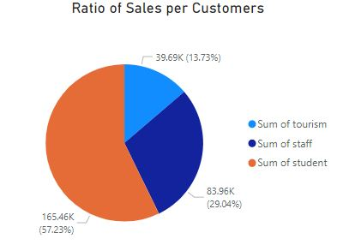

The graph above reflects total number of sales made from each type by customers, it answers the third question. From the following graph, it can be seen that the majority of Happy Cow sales from Students.

## **Sales Analysis of Seasonal Flavors:**

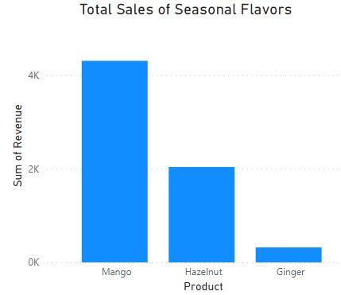

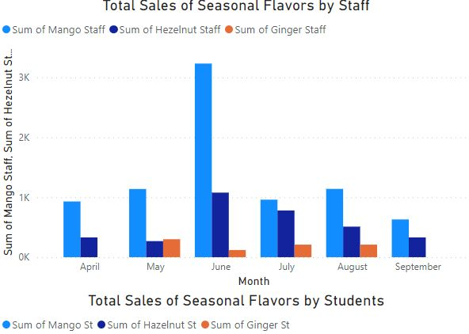

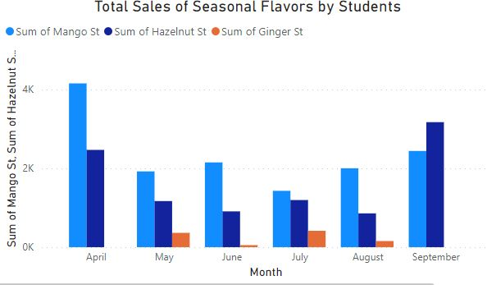

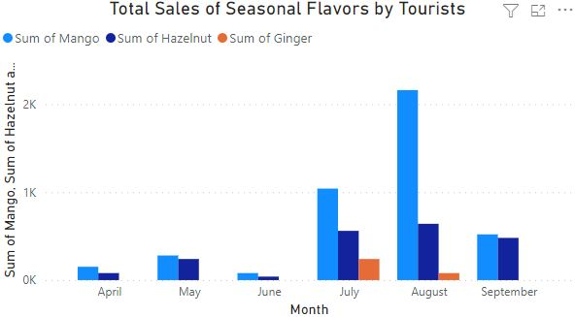

Happy Cow launched three seasonal flavors: hazelnut, ginger, and mango, which have varying needs throughout the year. The spring-autumn season sees the highest demand in April and September, but we can see that demand is stable and adequate throughout the year. Mangoes, being a summer fruit, are in high demand from June to August, which is Hong Kong's summer season. They are also in high demand in September, which is the end of summer and the start of autumn. Why didn't ginger sell out as much as we expected? It’s because ginger is meant to be popular in winters and the data given is not enough and does not contain winter month.

As can be seen, seasonal tastes have varying demands in various months, thus Happy Cow should introduce and preserve the flavors in accordance. For example, hazelnuts have the most demand in the spring and fall seasons, so they should only keep this flavor during those months and not all year. In the same manner that mango has its highest demand during the summer months, Happy Cow might make the taste accessible exclusively during those months and reduce it during the rest of the year, boosting sales and lowering manufacturing costs.

# **Dashboard Implementation**

The first dashboard contains the visualizations that studies the sales over different flavors, toppings, and packages. It contains three different graphs that belong to each customer group. This is a simple dashboard that only looks at the products analysis that is why there’s not much going on. These graphs can help make decisions like which flavors to stock more and which flavors to discontinue. It also helps understand the target audience too.

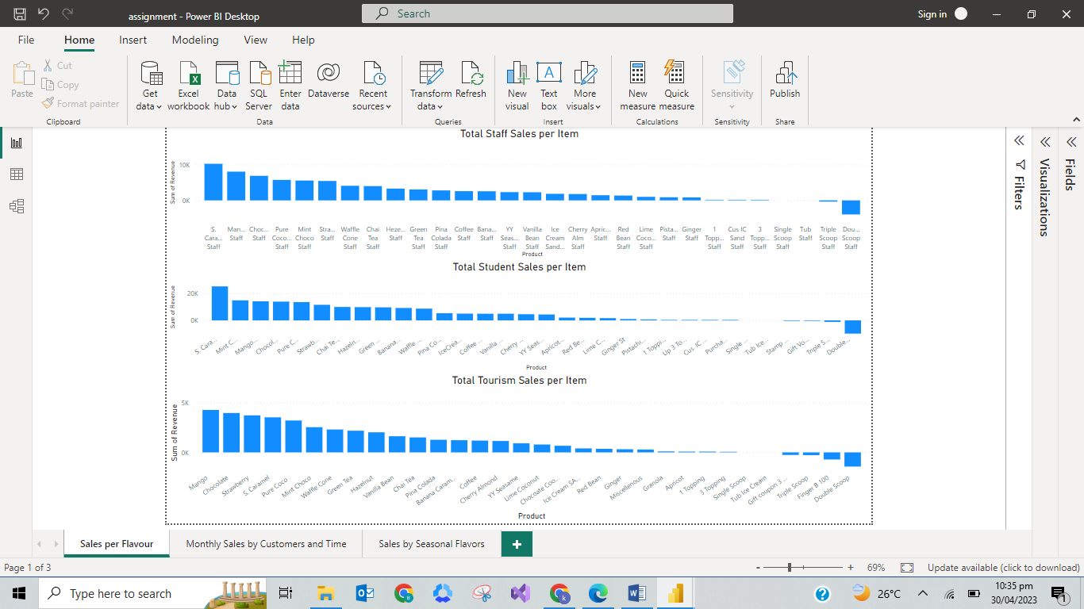

The second dashboard contains visualizations that study sales over a period of time. It contains a pie chart that represents the ratio of sales made from each group. The line chart is made using date hierarchy and can be drilled down to represent the sales made on daily basis in a month, it can help make decisions regarding which month to launch campaigns in, or what days/moths are better in terms of sales. Another visualization is the tree-map, this represents the total sales made by week, and this gives an idea as to which days are the busiest and when more employees should be called over. Lastly, the clustered bar chart represents the sales made over business hours. This helps understand when more help in terms of employees or stock is needed.

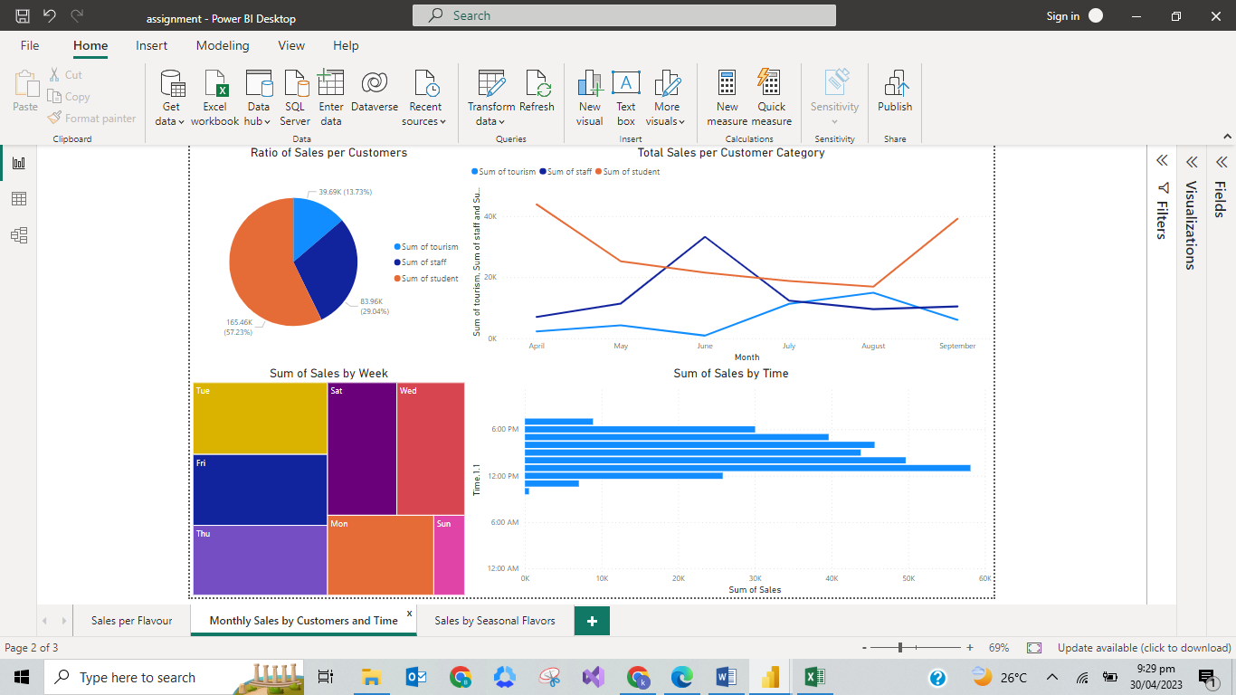

The third and the last dashboard contain four clustered column charts and one slicer. The slicer can be used to filter the graphs in this page by month. These visualization represents the information and results regarding the larger selection of seasonal flavors such as hazelnut, mango, and ginger of Happy Cow’s ice-creams. This helps us understand when these flavors are most popular and how are their sales in each customer category. By looking at this dashboard we can conclude that the most popular flavor is Mango in April, and it’s mostly bought by Students. Whereas, the least popular is Ginger, the reason for which we have already discussed above.

